|  |  |
| --- | --- |
| A picture of a winding road and trees  A Journey of hope | Group: 3  Suman Dhungel  Hoang Minh Long Vo  Quang Minh  Hoàng Vũ  Software 1  Python Game Project |

Table of Contents

Introduction: 2

Game Story: 2

Gameplay mechanics: 3

Specific goal of the game: 3

Game launch and Initial setup: 3

Game Rules: 3

Game flow: 4

Score calculation: 4

Data Storage: 5

Further Development Ideas: 5

A Journey of Hope

# Introduction:

**A Journey of Hope** is a text-based travel game where player takes on a role of a traveller who navigates through the airports around the world. The player must visit a maximum number of airports with a minimum carbon footprint. In this game, the player must combine the elements of strategy, resource management, and decision making.  
Game Overview:

* Type: Single Player, Travel Game, Strategy Formulation and Execution
* Console: Python Console
* Target Audience: All age-groups above twelve years who are interested in strategic games.

# Game Story:

The main three characters in the game are cancer patients who coincidently met at the same hospital for their treatment. Since all of them are in the process of curing their disease, they begin to have conversations with each other about their situation and how they caught cancer. After a brief conversation with each other, they realized that all three of them want to make the rest of their lives meaningful by travelling to places they always wanted to. However, they are also aware that environmental pollution is the root cause of increasing cancer in people. So, they produce an idea that they will try their best to limit their co2 consumption to the lowest while also travelling to as many places as possible within their budget and fuel.

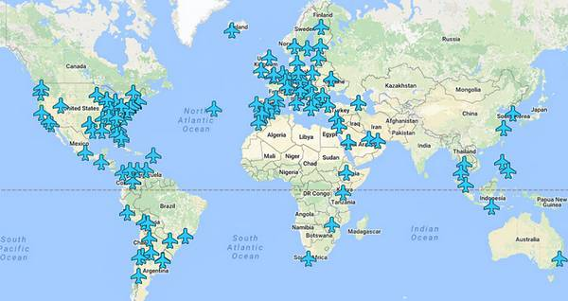

*Source: This picture by Unknown Author is licensed under* [*CC BY*](https://creativecommons.org/licenses/by/3.0/)

# Gameplay mechanics:

## Specific goal of the game:

The main goal of this game is to travel through all the designated airports using the shortest path possible while emitting lowest possible amount of CO2 and saving as much fuel and money as possible. Every decision is important to achieve a higher score in this eco-friendly challenge.

## Game launch and Initial setup:

* **Player Name:** Player enters their chosen name.
* **Starting Point:** Helsinki Vantaa Airport (EFHK)
* **Airport List:** Program provides randomly generated list of 12 airports from medium and large airports in the database. Or the player can also use the airport list used by the previous player.
* **Difficulty Levels:**

1. Easy (Henderson): Player gets $3000 to start the game.
2. Medium (Rosaline): Player gets $2000 to start the game.
3. Hard (Josh): Player gets $1000 to start the game.

* **Difficulty Multiplier:**
  + 1. Easy: 1
    2. Medium: 2
    3. Hard: 3
* **Fuel, CO2 emissions and Hints:** For all difficulty levels initial fuel is 1000 liters, CO2 emissions is 0kg and the player gets 3 hints to receive information about the nearest airport.

## Game Rules:

* **Traveling**:
  + Players must select from the list of available airports.
  + Distance traveled affects fuel consumption and CO2 emissions.
* **Fuel**:
  + Running out of fuel ends the game.
  + Players can purchase additional fuel if they have sufficient money.
* **Money**:
  + Player can use money for purchasing additional fuel and hints.
* **Hints**:
  + Hints are used to receive information on the nearest airport.
  + Player can purchase additional hints with the money.
* **Ending the Game**:
  + The game ends when the player chooses to stop traveling or runs out of fuel or has travelled all the airports.
* **Rewards**:
  + Player receives 100 liters of fuel after visiting every third airport.

# Game flow:

The game’s progression is represented in the diagram below: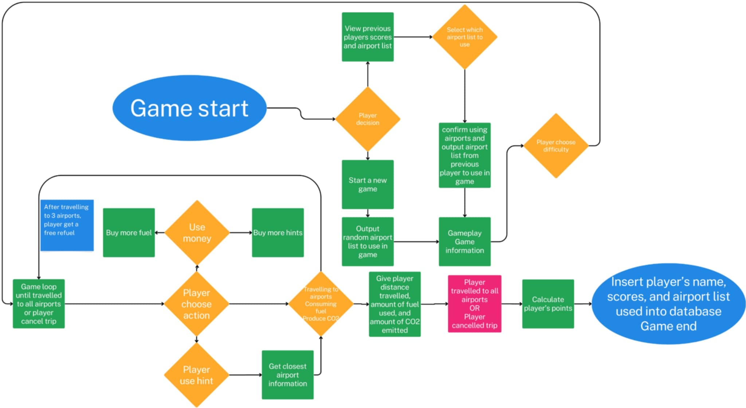

Figure 1: Game flow diagram.

# Score calculation:

The player’s final score is calculated by using following formula:

# Data Storage:

The database named flight_game is used in the game to fetch airport information for gameplay, storing of player scores and retrieving previous players’ airport list. The Entity Relationship Diagram of the database used in the game is presented below:

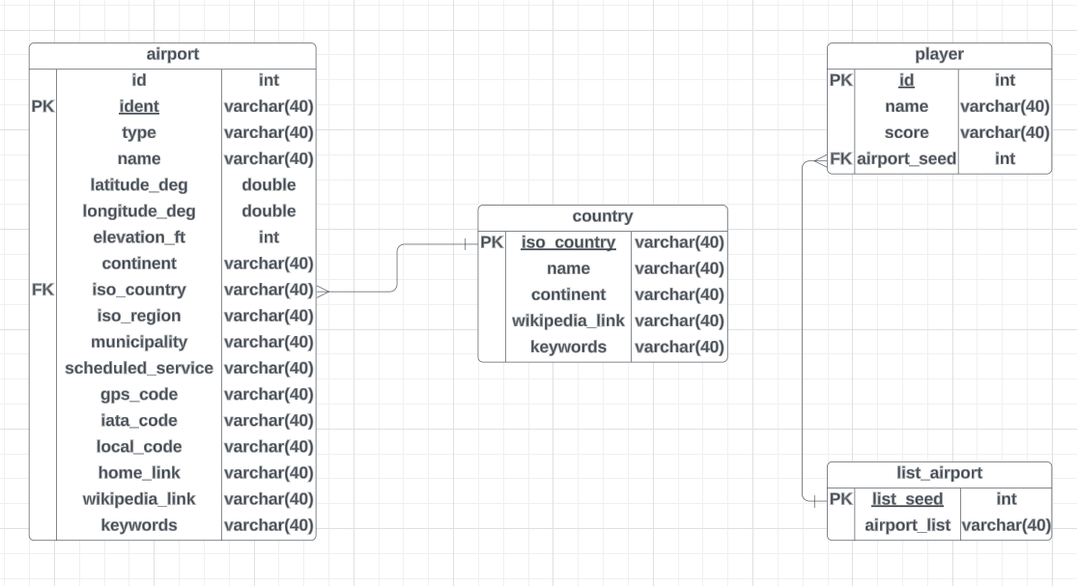

Figure 2: ER diagram of the flight_game database used in the game.

# Further Development Ideas:

* Include graphical user interface to make the game visually appealing and immersive.
* Incorporate background music into the game.
* Develop multiplayer mode and introduce player rankings.
* Add more difficulties and random events that affect the fuel and money.
* Implement achievements and milestones at different stages throughout the game.